|  |  |  |
| --- | --- | --- |
|  | **Carátula para entrega de prácticas** | |
| Facultad de Ingeniería | | Laboratorio de docencia |

Laboratorios de computación

Salas A y B

|  |  |
| --- | --- |
| *Profesor:* | Cruz Carlon Juan Alfredo M.C. |
| *Asignatura:* | Fundamentos de Programación |
| *Grupo:* | 1107 |
| *No de Práctica(s):* | 12 |
| *Integrante(s):* | Moreno Martínez Ingrid Zacnité |
|  |  |
|  |  |
| *Semestre:* | 2018-1 |
| *Fecha de entrega:* | 28/Noviembre/ 2017 |
| *Observaciones:* |  |
|  |  |

CALIFICACIÓN: __________

#include "cache.h" //

#undef DEBUG_85

#ifdef DEBUG_85

#define say(a) fprintf(stderr, a)

#define say1(a,b) fprintf(stderr, a, b)

#define say2(a,b,c) fprintf(stderr, a, b, c)

#else

#define say(a) do { /* nothing */ } while (0)

#define say1(a,b) do { /* nothing */ } while (0)

#define say2(a,b,c) do { /* nothing */ } while (0)

#endif

static const char en85[] = {

'0', '1', '2', '3', '4', '5', '6', '7', '8', '9',

'A', 'B', 'C', 'D', 'E', 'F', 'G', 'H', 'I', 'J',

'K', 'L', 'M', 'N', 'O', 'P', 'Q', 'R', 'S', 'T',

'U', 'V', 'W', 'X', 'Y', 'Z',

'a', 'b', 'c', 'd', 'e', 'f', 'g', 'h', 'i', 'j',

'k', 'l', 'm', 'n', 'o', 'p', 'q', 'r', 's', 't',

'u', 'v', 'w', 'x', 'y', 'z',

'!', '#', '$', '%', '&', '(', ')', '*', '+', '-',

';', '<', '=', '>', '?', '@', '^', '_', '`', '{',

'|', '}', '~'

}:{

static char de85[256];

static void prep_base85(void)

{

int i;

if (de85['Z'])

return;

for (i = 0; i < ARRAY_SIZE(en85); i++) {

int ch = en85[i];

de85[ch] = i + 1;

}

}

int decode_85(char *dst, const char *buffer, int len)

{

prep_base85();

say2("decode 85 <%.*s>", len / 4 * 5, buffer);

while (len) {

unsigned acc = 0;

int de, cnt = 4;

unsigned char ch;

do {

ch = *buffer++;

de = de85[ch];

if (--de < 0)

return error("invalid base85 alphabet %c", ch);

acc = acc * 85 + de;

} while (--cnt);

ch = *buffer++;

de = de85[ch];

if (--de < 0)

return error("invalid base85 alphabet %c", ch);

/* Detect overflow. */

if (0xffffffff / 85 < acc ||

0xffffffff - de < (acc *= 85))

return error("invalid base85 sequence %.5s", buffer-5);

acc += de;

say1(" %08x", acc);

cnt = (len < 4) ? len : 4;

len -= cnt;

do {

acc = (acc << 8) | (acc >> 24);

*dst++ = acc;

} while (--cnt);

}

say("\n");

return 0;

}

void encode_85(char *buf, const unsigned char *data, int bytes)

{

say("encode 85");

while (bytes) {

unsigned acc = 0;

int cnt;

for (cnt = 24; cnt >= 0; cnt -= 8) {

unsigned ch = *data++;

acc |= ch << cnt;

if (--bytes == 0)

break;

}

say1(" %08x", acc);

for (cnt = 4; cnt >= 0; cnt--) {

int val = acc % 85;

acc /= 85;

buf[cnt] = en85[val];

}

buf += 5;

}

say("\n");

*buf = 0;

}

#ifdef DEBUG_85

int main(int ac, char **av)

{

char buf[1024];

if (!strcmp(av[1], "-e")) {

int len = strlen(av[2]);

encode_85(buf, av[2], len);

if (len <= 26) len = len + 'A' - 1;

else len = len + 'a' - 26 - 1;

printf("encoded: %c%s\n", len, buf);

return 0;

}

if (!strcmp(av[1], "-d")) {

int len = *av[2];

if ('A' <= len && len <= 'Z') len = len - 'A' + 1;

else len = len - 'a' + 26 + 1;

decode_85(buf, av[2]+1, len);

printf("decoded: %.*s\n", len, buf);

return 0;

}

if (!strcmp(av[1], "-t")) {

char t[4] = { -1,-1,-1,-1 };

encode_85(buf, t, 4);

printf("encoded: D%s\n", buf);

return 0;

}

}

#endif

Diagrama de flujo

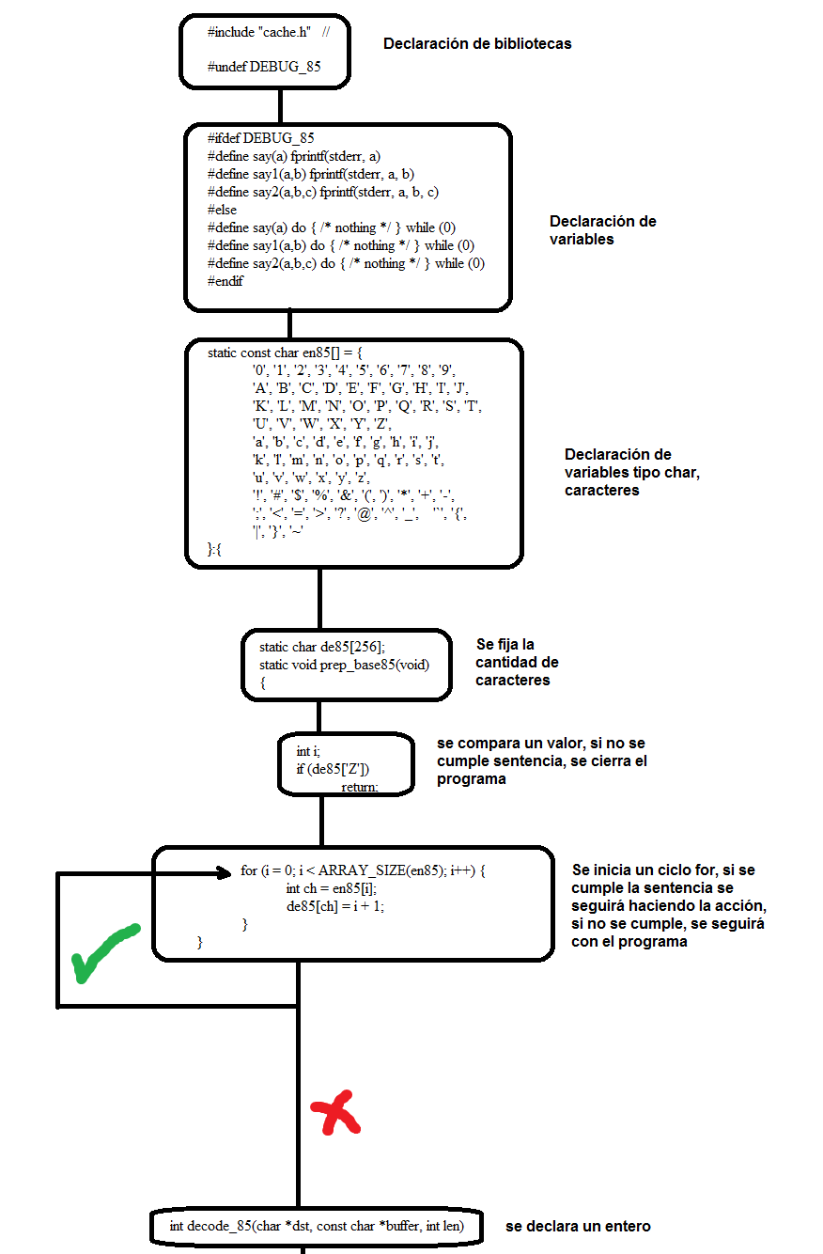

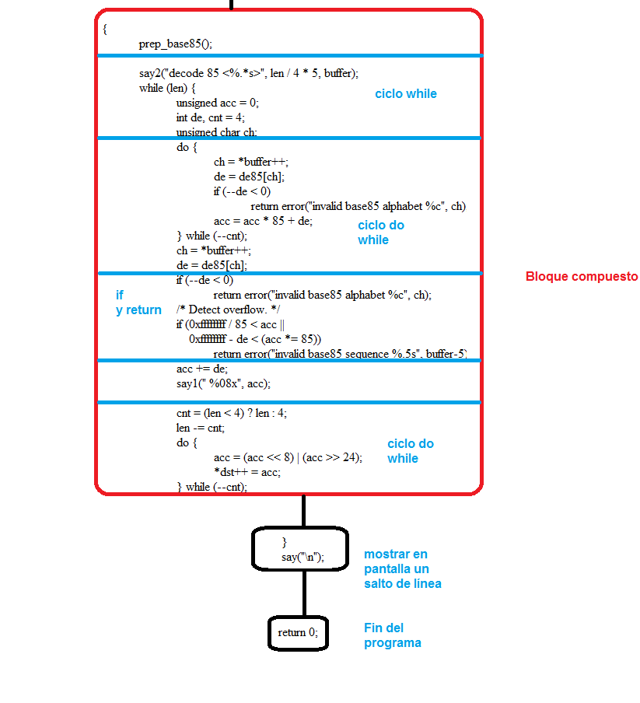

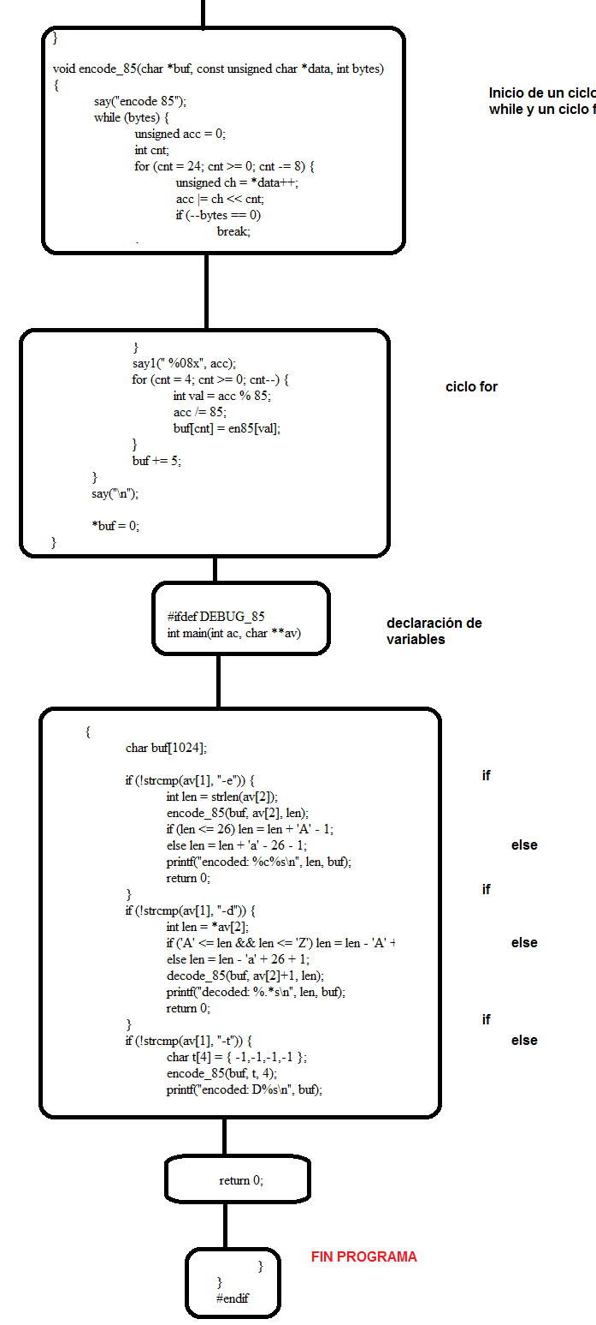

Funciones llamadas:

If

While

Do-While

Return

/*

*

* Bluetooth support for Broadcom devices

*

* Copyright (C) 2015 Intel Corporation

*

*

* This program is free software; you can redistribute it and/or modify

* it under the terms of the GNU General Public License as published by

* the Free Software Foundation; either version 2 of the License, or

* (at your option) any later version.

*

* This program is distributed in the hope that it will be useful,

* but WITHOUT ANY WARRANTY; without even the implied warranty of

* MERCHANTABILITY or FITNESS FOR A PARTICULAR PURPOSE. See the

* GNU General Public License for more details.

*

* You should have received a copy of the GNU General Public License

* along with this program; if not, write to the Free Software

* Foundation, Inc., 59 Temple Place, Suite 330, Boston, MA 02111-1307 USA

*

*/

#include <linux/module.h>

#include <linux/firmware.h>

#include <asm/unaligned.h>

#include <net/bluetooth/bluetooth.h>

#include <net/bluetooth/hci_core.h>

#include "btbcm.h"

#define VERSION "0.1"

#define BDADDR_BCM20702A0 (&(bdaddr_t) {{0x00, 0xa0, 0x02, 0x70, 0x20, 0x00}})

#define BDADDR_BCM4324B3 (&(bdaddr_t) {{0x00, 0x00, 0x00, 0xb3, 0x24, 0x43}})

#define BDADDR_BCM4330B1 (&(bdaddr_t) {{0x00, 0x00, 0x00, 0xb1, 0x30, 0x43}})

int btbcm_check_bdaddr(struct hci_dev *hdev)

{

struct hci_rp_read_bd_addr *bda;

struct sk_buff *skb;

skb = __hci_cmd_sync(hdev, HCI_OP_READ_BD_ADDR, 0, NULL,

HCI_INIT_TIMEOUT);

if (IS_ERR(skb)) {

int err = PTR_ERR(skb);

bt_dev_err(hdev, "BCM: Reading device address failed (%d)", err);

return err;

}

if (skb->len != sizeof(*bda)) {

bt_dev_err(hdev, "BCM: Device address length mismatch");

kfree_skb(skb);

return -EIO;

}

bda = (struct hci_rp_read_bd_addr *)skb->data;

/* Check if the address indicates a controller with either an

* invalid or default address. In both cases the device needs

* to be marked as not having a valid address.

*

* The address 00:20:70:02:A0:00 indicates a BCM20702A0 controller

* with no configured address.

*

* The address 43:24:B3:00:00:00 indicates a BCM4324B3 controller

* with waiting for configuration state.

*

* The address 43:30:B1:00:00:00 indicates a BCM4330B1 controller

* with waiting for configuration state.

*/

if (!bacmp(&bda->bdaddr, BDADDR_BCM20702A0) ||

!bacmp(&bda->bdaddr, BDADDR_BCM4324B3) ||

!bacmp(&bda->bdaddr, BDADDR_BCM4330B1)) {

bt_dev_info(hdev, "BCM: Using default device address (%pMR)",

&bda->bdaddr);

set_bit(HCI_QUIRK_INVALID_BDADDR, &hdev->quirks);

}

kfree_skb(skb);

return 0;

}

EXPORT_SYMBOL_GPL(btbcm_check_bdaddr);

int btbcm_set_bdaddr(struct hci_dev *hdev, const bdaddr_t *bdaddr)

{

struct sk_buff *skb;

int err;

skb = __hci_cmd_sync(hdev, 0xfc01, 6, bdaddr, HCI_INIT_TIMEOUT);

if (IS_ERR(skb)) {

err = PTR_ERR(skb);

bt_dev_err(hdev, "BCM: Change address command failed (%d)", err);

return err;

}

kfree_skb(skb);

return 0;

}

EXPORT_SYMBOL_GPL(btbcm_set_bdaddr);

int btbcm_patchram(struct hci_dev *hdev, const struct firmware *fw)

{

const struct hci_command_hdr *cmd;

const u8 *fw_ptr;

size_t fw_size;

struct sk_buff *skb;

u16 opcode;

int err = 0;

/* Start Download */

skb = __hci_cmd_sync(hdev, 0xfc2e, 0, NULL, HCI_INIT_TIMEOUT);

if (IS_ERR(skb)) {

err = PTR_ERR(skb);

bt_dev_err(hdev, "BCM: Download Minidrv command failed (%d)",

err);

goto done;

}

kfree_skb(skb);

/* 50 msec delay after Download Minidrv completes */

msleep(50);

fw_ptr = fw->data;

fw_size = fw->size;

while (fw_size >= sizeof(*cmd)) {

const u8 *cmd_param;

cmd = (struct hci_command_hdr *)fw_ptr;

fw_ptr += sizeof(*cmd);

fw_size -= sizeof(*cmd);

if (fw_size < cmd->plen) {

bt_dev_err(hdev, "BCM: Patch is corrupted");

err = -EINVAL;

goto done;

}

cmd_param = fw_ptr;

fw_ptr += cmd->plen;

fw_size -= cmd->plen;

opcode = le16_to_cpu(cmd->opcode);

skb = __hci_cmd_sync(hdev, opcode, cmd->plen, cmd_param,

HCI_INIT_TIMEOUT);

if (IS_ERR(skb)) {

err = PTR_ERR(skb);

bt_dev_err(hdev, "BCM: Patch command %04x failed (%d)",

opcode, err);

goto done;

}

kfree_skb(skb);

}

/* 250 msec delay after Launch Ram completes */

msleep(250);

done:

return err;

}

EXPORT_SYMBOL(btbcm_patchram);

static int btbcm_reset(struct hci_dev *hdev)

{

struct sk_buff *skb;

skb = __hci_cmd_sync(hdev, HCI_OP_RESET, 0, NULL, HCI_INIT_TIMEOUT);

if (IS_ERR(skb)) {

int err = PTR_ERR(skb);

bt_dev_err(hdev, "BCM: Reset failed (%d)", err);

return err;

}

kfree_skb(skb);

/* 100 msec delay for module to complete reset process */

msleep(100);

return 0;

}

static struct sk_buff *btbcm_read_local_name(struct hci_dev *hdev)

{

struct sk_buff *skb;

skb = __hci_cmd_sync(hdev, HCI_OP_READ_LOCAL_NAME, 0, NULL,

HCI_INIT_TIMEOUT);

if (IS_ERR(skb)) {

bt_dev_err(hdev, "BCM: Reading local name failed (%ld)",

PTR_ERR(skb));

return skb;

}

if (skb->len != sizeof(struct hci_rp_read_local_name)) {

bt_dev_err(hdev, "BCM: Local name length mismatch");

kfree_skb(skb);

return ERR_PTR(-EIO);

}

return skb;

}

static struct sk_buff *btbcm_read_local_version(struct hci_dev *hdev)

{

struct sk_buff *skb;

skb = __hci_cmd_sync(hdev, HCI_OP_READ_LOCAL_VERSION, 0, NULL,

HCI_INIT_TIMEOUT);

if (IS_ERR(skb)) {

bt_dev_err(hdev, "BCM: Reading local version info failed (%ld)",

PTR_ERR(skb));

return skb;

}

if (skb->len != sizeof(struct hci_rp_read_local_version)) {

bt_dev_err(hdev, "BCM: Local version length mismatch");

kfree_skb(skb);

return ERR_PTR(-EIO);

}

return skb;

}

static struct sk_buff *btbcm_read_verbose_config(struct hci_dev *hdev)

{

struct sk_buff *skb;

skb = __hci_cmd_sync(hdev, 0xfc79, 0, NULL, HCI_INIT_TIMEOUT);

if (IS_ERR(skb)) {

bt_dev_err(hdev, "BCM: Read verbose config info failed (%ld)",

PTR_ERR(skb));

return skb;

}

if (skb->len != 7) {

bt_dev_err(hdev, "BCM: Verbose config length mismatch");

kfree_skb(skb);

return ERR_PTR(-EIO);

}

return skb;

}

static struct sk_buff *btbcm_read_controller_features(struct hci_dev *hdev)

{

struct sk_buff *skb;

skb = __hci_cmd_sync(hdev, 0xfc6e, 0, NULL, HCI_INIT_TIMEOUT);

if (IS_ERR(skb)) {

bt_dev_err(hdev, "BCM: Read controller features failed (%ld)",

PTR_ERR(skb));

return skb;

}

if (skb->len != 9) {

bt_dev_err(hdev, "BCM: Controller features length mismatch");

kfree_skb(skb);

return ERR_PTR(-EIO);

}

return skb;

}

static struct sk_buff *btbcm_read_usb_product(struct hci_dev *hdev)

{

struct sk_buff *skb;

skb = __hci_cmd_sync(hdev, 0xfc5a, 0, NULL, HCI_INIT_TIMEOUT);

if (IS_ERR(skb)) {

bt_dev_err(hdev, "BCM: Read USB product info failed (%ld)",

PTR_ERR(skb));

return skb;

}

if (skb->len != 5) {

bt_dev_err(hdev, "BCM: USB product length mismatch");

kfree_skb(skb);

return ERR_PTR(-EIO);

}

return skb;

}

static int btbcm_read_info(struct hci_dev *hdev)

{

struct sk_buff *skb;

/* Read Verbose Config Version Info */

skb = btbcm_read_verbose_config(hdev);

if (IS_ERR(skb))

return PTR_ERR(skb);

bt_dev_info(hdev, "BCM: chip id %u", skb->data[1]);

kfree_skb(skb);

/* Read Controller Features */

skb = btbcm_read_controller_features(hdev);

if (IS_ERR(skb))

return PTR_ERR(skb);

bt_dev_info(hdev, "BCM: features 0x%2.2x", skb->data[1]);

kfree_skb(skb);

/* Read Local Name */

skb = btbcm_read_local_name(hdev);

if (IS_ERR(skb))

return PTR_ERR(skb);

bt_dev_info(hdev, "%s", (char *)(skb->data + 1));

kfree_skb(skb);

return 0;

}

static const struct {

u16 subver;

const char *name;

} bcm_uart_subver_table[] = {

{ 0x4103, "BCM4330B1" }, /* 002.001.003 */

{ 0x410e, "BCM43341B0" }, /* 002.001.014 */

{ 0x4406, "BCM4324B3" }, /* 002.004.006 */

{ 0x610c, "BCM4354" }, /* 003.001.012 */

{ 0x2209, "BCM43430A1" }, /* 001.002.009 */

{ 0x6119, "BCM4345C0" }, /* 003.001.025 */

{ 0x230f, "BCM4356A2" }, /* 001.003.015 */

{ }

};

int btbcm_initialize(struct hci_dev *hdev, char *fw_name, size_t len)

{

u16 subver, rev;

const char *hw_name = NULL;

struct sk_buff *skb;

struct hci_rp_read_local_version *ver;

int i, err;

/* Reset */

err = btbcm_reset(hdev);

if (err)

return err;

/* Read Local Version Info */

skb = btbcm_read_local_version(hdev);

if (IS_ERR(skb))

return PTR_ERR(skb);

ver = (struct hci_rp_read_local_version *)skb->data;

rev = le16_to_cpu(ver->hci_rev);

subver = le16_to_cpu(ver->lmp_subver);

kfree_skb(skb);

/* Read controller information */

err = btbcm_read_info(hdev);

if (err)

return err;

switch ((rev & 0xf000) >> 12) {

case 0:

case 1:

case 2:

case 3:

for (i = 0; bcm_uart_subver_table[i].name; i++) {

if (subver == bcm_uart_subver_table[i].subver) {

hw_name = bcm_uart_subver_table[i].name;

break;

}

}

snprintf(fw_name, len, "brcm/%s.hcd", hw_name ? : "BCM");

break;

default:

return 0;

}

bt_dev_info(hdev, "%s (%3.3u.%3.3u.%3.3u) build %4.4u",

hw_name ? : "BCM", (subver & 0xe000) >> 13,

(subver & 0x1f00) >> 8, (subver & 0x00ff), rev & 0x0fff);

return 0;

}

EXPORT_SYMBOL_GPL(btbcm_initialize);

int btbcm_finalize(struct hci_dev *hdev)

{

struct sk_buff *skb;

struct hci_rp_read_local_version *ver;

u16 subver, rev;

int err;

/* Reset */

err = btbcm_reset(hdev);

if (err)

return err;

/* Read Local Version Info */

skb = btbcm_read_local_version(hdev);

if (IS_ERR(skb))

return PTR_ERR(skb);

ver = (struct hci_rp_read_local_version *)skb->data;

rev = le16_to_cpu(ver->hci_rev);

subver = le16_to_cpu(ver->lmp_subver);

kfree_skb(skb);

bt_dev_info(hdev, "BCM (%3.3u.%3.3u.%3.3u) build %4.4u",

(subver & 0xe000) >> 13, (subver & 0x1f00) >> 8,

(subver & 0x00ff), rev & 0x0fff);

btbcm_check_bdaddr(hdev);

set_bit(HCI_QUIRK_STRICT_DUPLICATE_FILTER, &hdev->quirks);

return 0;

}

EXPORT_SYMBOL_GPL(btbcm_finalize);

static const struct {

u16 subver;

const char *name;

} bcm_usb_subver_table[] = {

{ 0x210b, "BCM43142A0" }, /* 001.001.011 */

{ 0x2112, "BCM4314A0" }, /* 001.001.018 */

{ 0x2118, "BCM20702A0" }, /* 001.001.024 */

{ 0x2126, "BCM4335A0" }, /* 001.001.038 */

{ 0x220e, "BCM20702A1" }, /* 001.002.014 */

{ 0x230f, "BCM4354A2" }, /* 001.003.015 */

{ 0x4106, "BCM4335B0" }, /* 002.001.006 */

{ 0x410e, "BCM20702B0" }, /* 002.001.014 */

{ 0x6109, "BCM4335C0" }, /* 003.001.009 */

{ 0x610c, "BCM4354" }, /* 003.001.012 */

{ }

};

int btbcm_setup_patchram(struct hci_dev *hdev)

{

char fw_name[64];

const struct firmware *fw;

u16 subver, rev, pid, vid;

const char *hw_name = NULL;

struct sk_buff *skb;

struct hci_rp_read_local_version *ver;

int i, err;

/* Reset */

err = btbcm_reset(hdev);

if (err)

return err;

/* Read Local Version Info */

skb = btbcm_read_local_version(hdev);

if (IS_ERR(skb))

return PTR_ERR(skb);

ver = (struct hci_rp_read_local_version *)skb->data;

rev = le16_to_cpu(ver->hci_rev);

subver = le16_to_cpu(ver->lmp_subver);

kfree_skb(skb);

/* Read controller information */

err = btbcm_read_info(hdev);

if (err)

return err;

switch ((rev & 0xf000) >> 12) {

case 0:

case 3:

for (i = 0; bcm_uart_subver_table[i].name; i++) {

if (subver == bcm_uart_subver_table[i].subver) {

hw_name = bcm_uart_subver_table[i].name;

break;

}

}

snprintf(fw_name, sizeof(fw_name), "brcm/%s.hcd",

hw_name ? : "BCM");

break;

case 1:

case 2:

/* Read USB Product Info */

skb = btbcm_read_usb_product(hdev);

if (IS_ERR(skb))

return PTR_ERR(skb);

vid = get_unaligned_le16(skb->data + 1);

pid = get_unaligned_le16(skb->data + 3);

kfree_skb(skb);

for (i = 0; bcm_usb_subver_table[i].name; i++) {

if (subver == bcm_usb_subver_table[i].subver) {

hw_name = bcm_usb_subver_table[i].name;

break;

}

}

snprintf(fw_name, sizeof(fw_name), "brcm/%s-%4.4x-%4.4x.hcd",

hw_name ? : "BCM", vid, pid);

break;

default:

return 0;

}

bt_dev_info(hdev, "%s (%3.3u.%3.3u.%3.3u) build %4.4u",

hw_name ? : "BCM", (subver & 0xe000) >> 13,

(subver & 0x1f00) >> 8, (subver & 0x00ff), rev & 0x0fff);

err = request_firmware(&fw, fw_name, &hdev->dev);

if (err < 0) {

bt_dev_info(hdev, "BCM: Patch %s not found", fw_name);

goto done;

}

btbcm_patchram(hdev, fw);

release_firmware(fw);

/* Reset */

err = btbcm_reset(hdev);

if (err)

return err;

/* Read Local Version Info */

skb = btbcm_read_local_version(hdev);

if (IS_ERR(skb))

return PTR_ERR(skb);

ver = (struct hci_rp_read_local_version *)skb->data;

rev = le16_to_cpu(ver->hci_rev);

subver = le16_to_cpu(ver->lmp_subver);

kfree_skb(skb);

bt_dev_info(hdev, "%s (%3.3u.%3.3u.%3.3u) build %4.4u",

hw_name ? : "BCM", (subver & 0xe000) >> 13,

(subver & 0x1f00) >> 8, (subver & 0x00ff), rev & 0x0fff);

/* Read Local Name */

skb = btbcm_read_local_name(hdev);

if (IS_ERR(skb))

return PTR_ERR(skb);

bt_dev_info(hdev, "%s", (char *)(skb->data + 1));

kfree_skb(skb);

done:

btbcm_check_bdaddr(hdev);

set_bit(HCI_QUIRK_STRICT_DUPLICATE_FILTER, &hdev->quirks);

return 0;

}

EXPORT_SYMBOL_GPL(btbcm_setup_patchram);

int btbcm_setup_apple(struct hci_dev *hdev)

{

struct sk_buff *skb;

int err;

/* Reset */

err = btbcm_reset(hdev);

if (err)

return err;

/* Read Verbose Config Version Info */

skb = btbcm_read_verbose_config(hdev);

if (!IS_ERR(skb)) {

bt_dev_info(hdev, "BCM: chip id %u build %4.4u",

skb->data[1], get_unaligned_le16(skb->data + 5));

kfree_skb(skb);

}

/* Read USB Product Info */

skb = btbcm_read_usb_product(hdev);

if (!IS_ERR(skb)) {

bt_dev_info(hdev, "BCM: product %4.4x:%4.4x",

get_unaligned_le16(skb->data + 1),

get_unaligned_le16(skb->data + 3));

kfree_skb(skb);

}

/* Read Controller Features */

skb = btbcm_read_controller_features(hdev);

if (!IS_ERR(skb)) {

bt_dev_info(hdev, "BCM: features 0x%2.2x", skb->data[1]);

kfree_skb(skb);

}

/* Read Local Name */

skb = btbcm_read_local_name(hdev);

if (!IS_ERR(skb)) {

bt_dev_info(hdev, "%s", (char *)(skb->data + 1));

kfree_skb(skb);

}

set_bit(HCI_QUIRK_STRICT_DUPLICATE_FILTER, &hdev->quirks);

return 0;

}

EXPORT_SYMBOL_GPL(btbcm_setup_apple);

MODULE_AUTHOR("Marcel Holtmann <marcel@holtmann.org>");

MODULE_DESCRIPTION("Bluetooth support for Broadcom devices ver " VERSION);

MODULE_VERSION(VERSION);

MODULE_LICENSE("GPL");

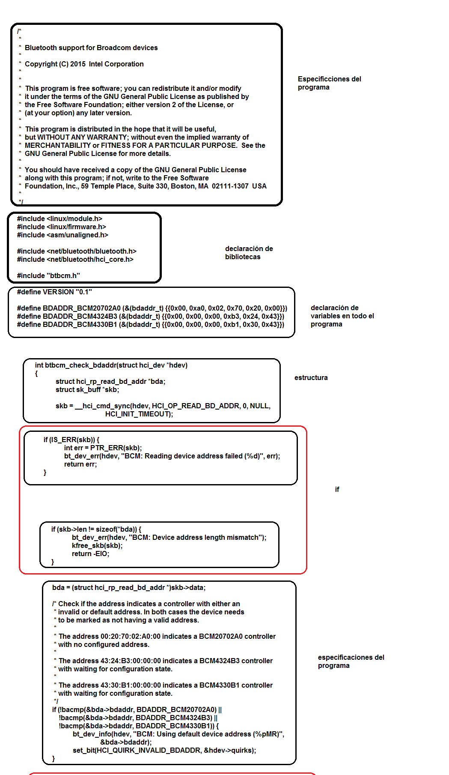

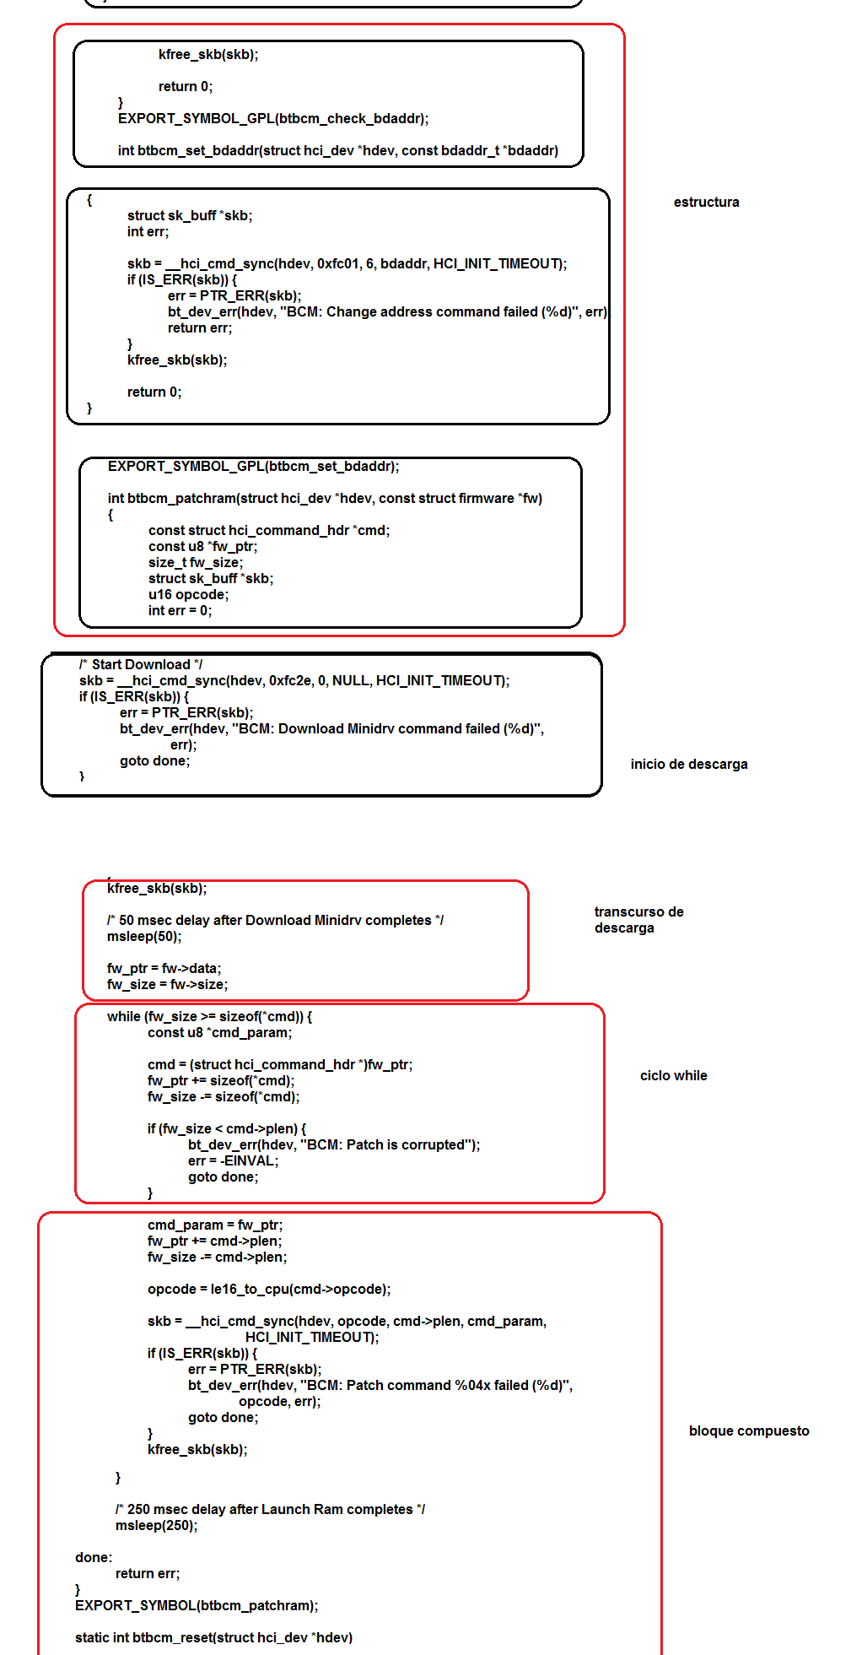

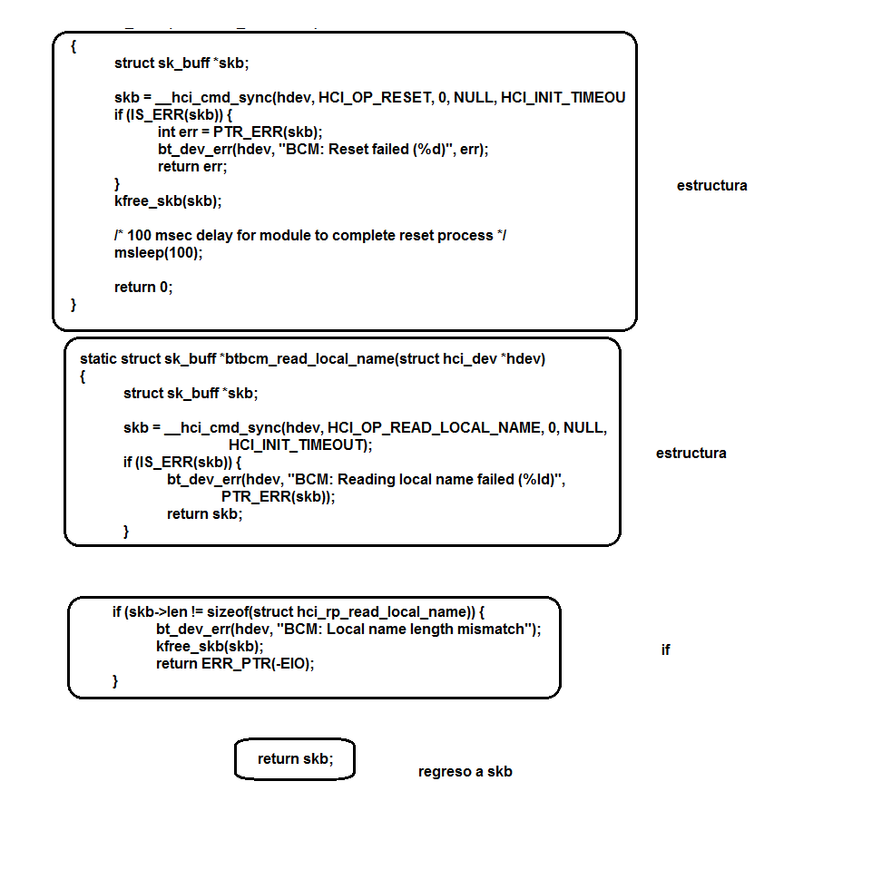

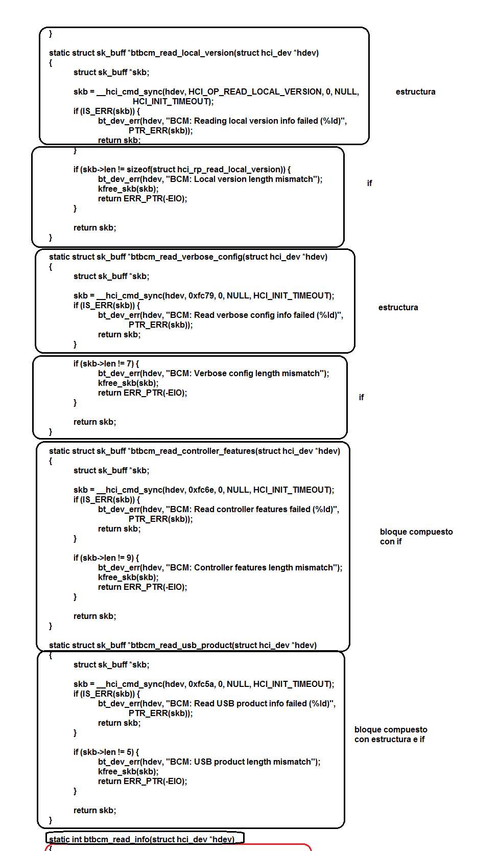

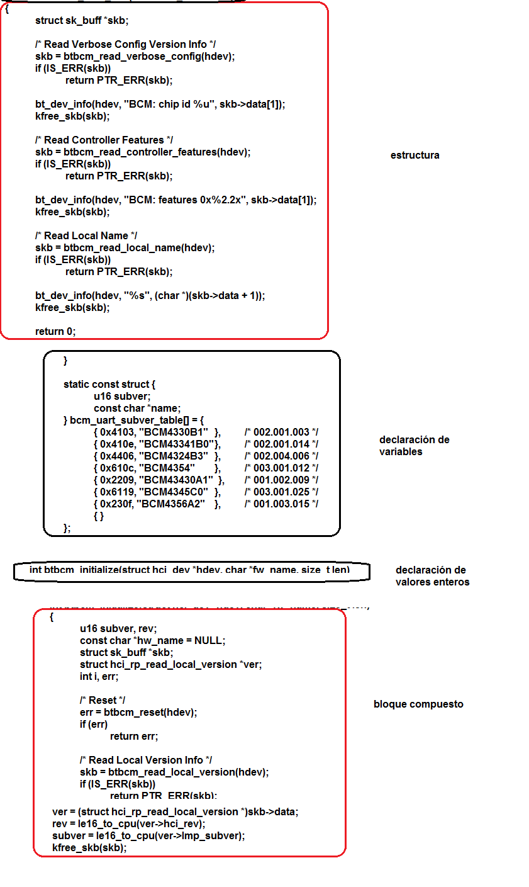

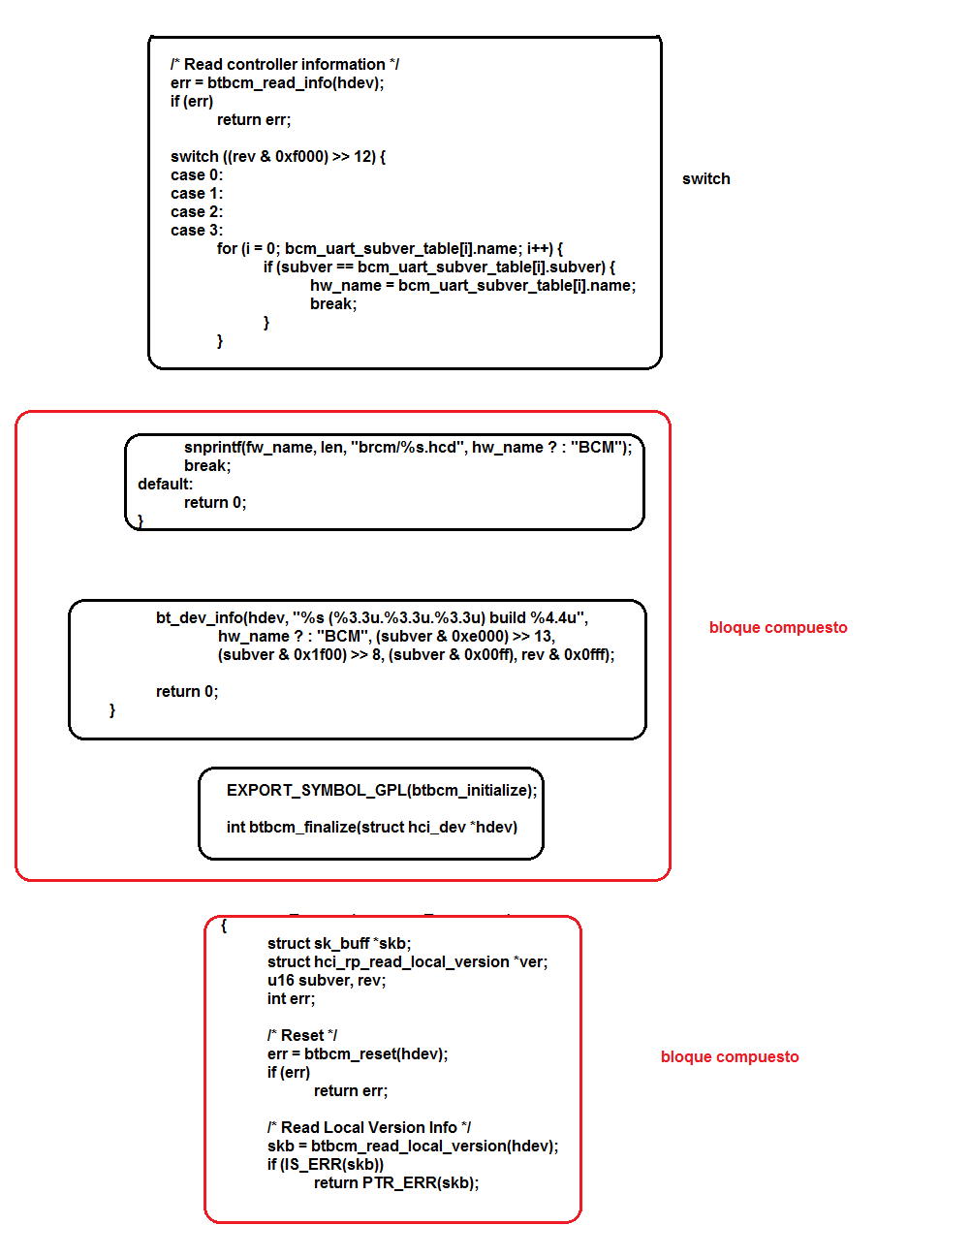

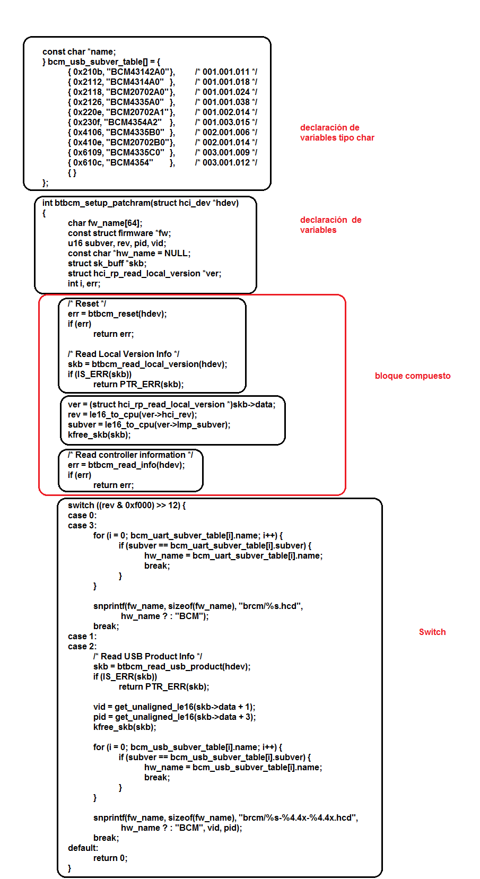

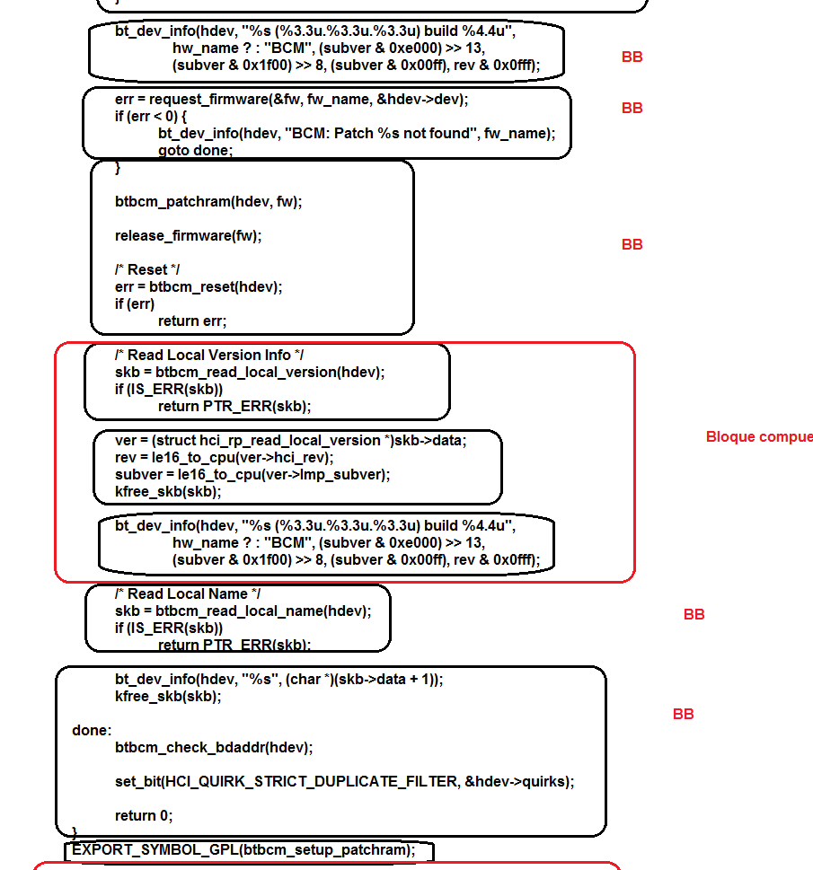

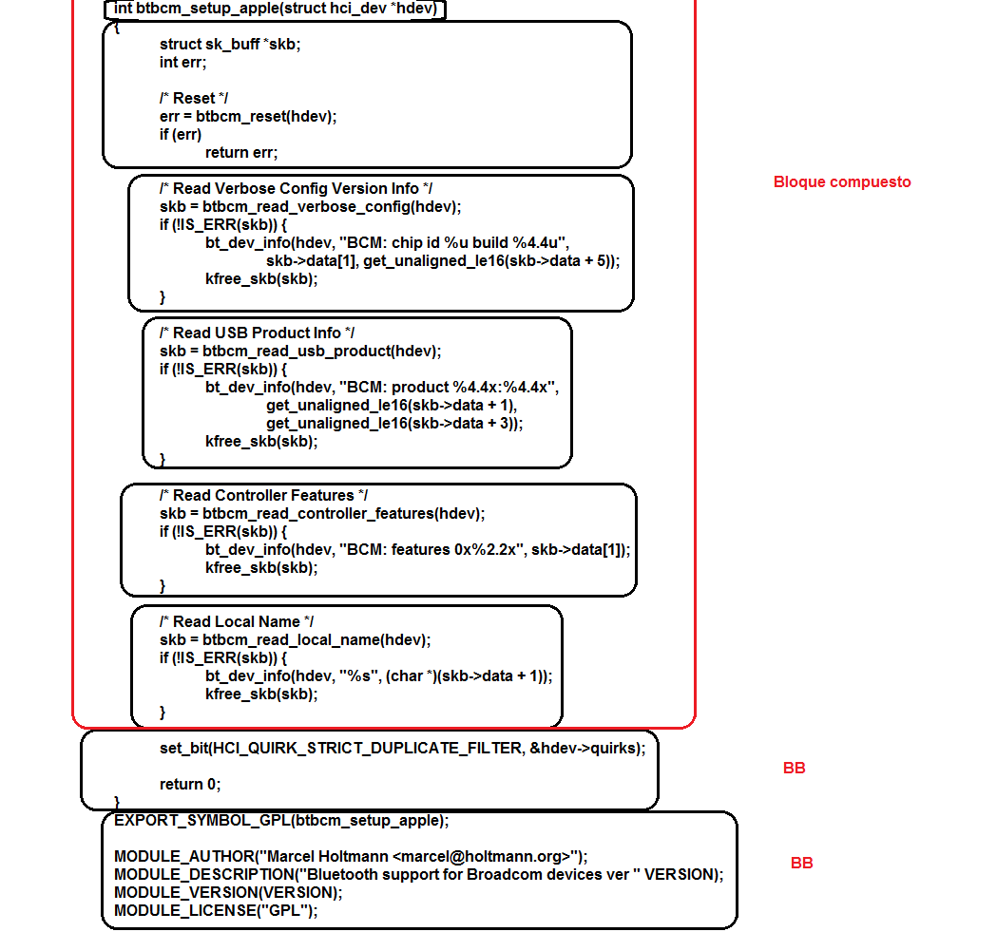

Funciones que llama:

If

Switch

Structure

While

Do-While

Return

¿Por qué una función no es un programa?

Una función sólo realiza una acción, una operación con los valores de las variables que se quieren analizar en el programa mientras que un programa, es un conjunto de operaciones y demás acciones, todo un proceso con un fin específico, que al dividirse en pasos, se divide en operaciones y en funciones.